Pick and Place Project 2016

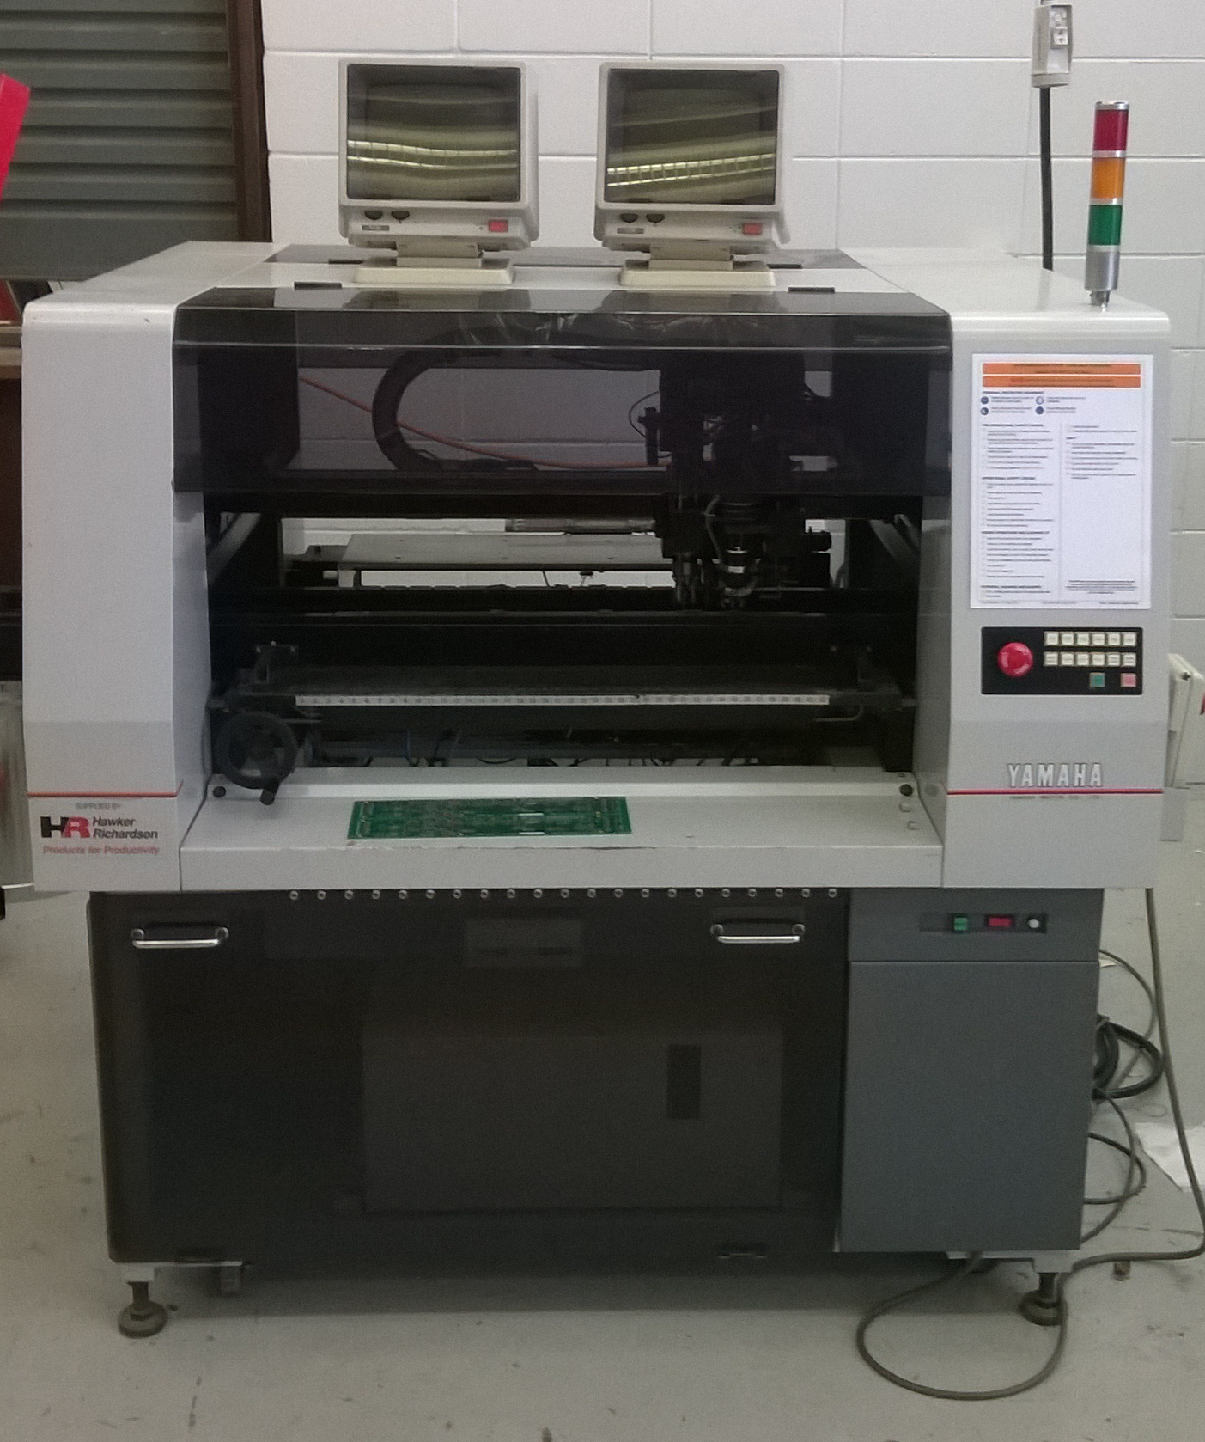

Pick and place project 2016

Identify project

Pricing and Procurement

Identify problems

Circuit diagram

PCB design

Software design

Build prototype

Conclusion